Single number 2:

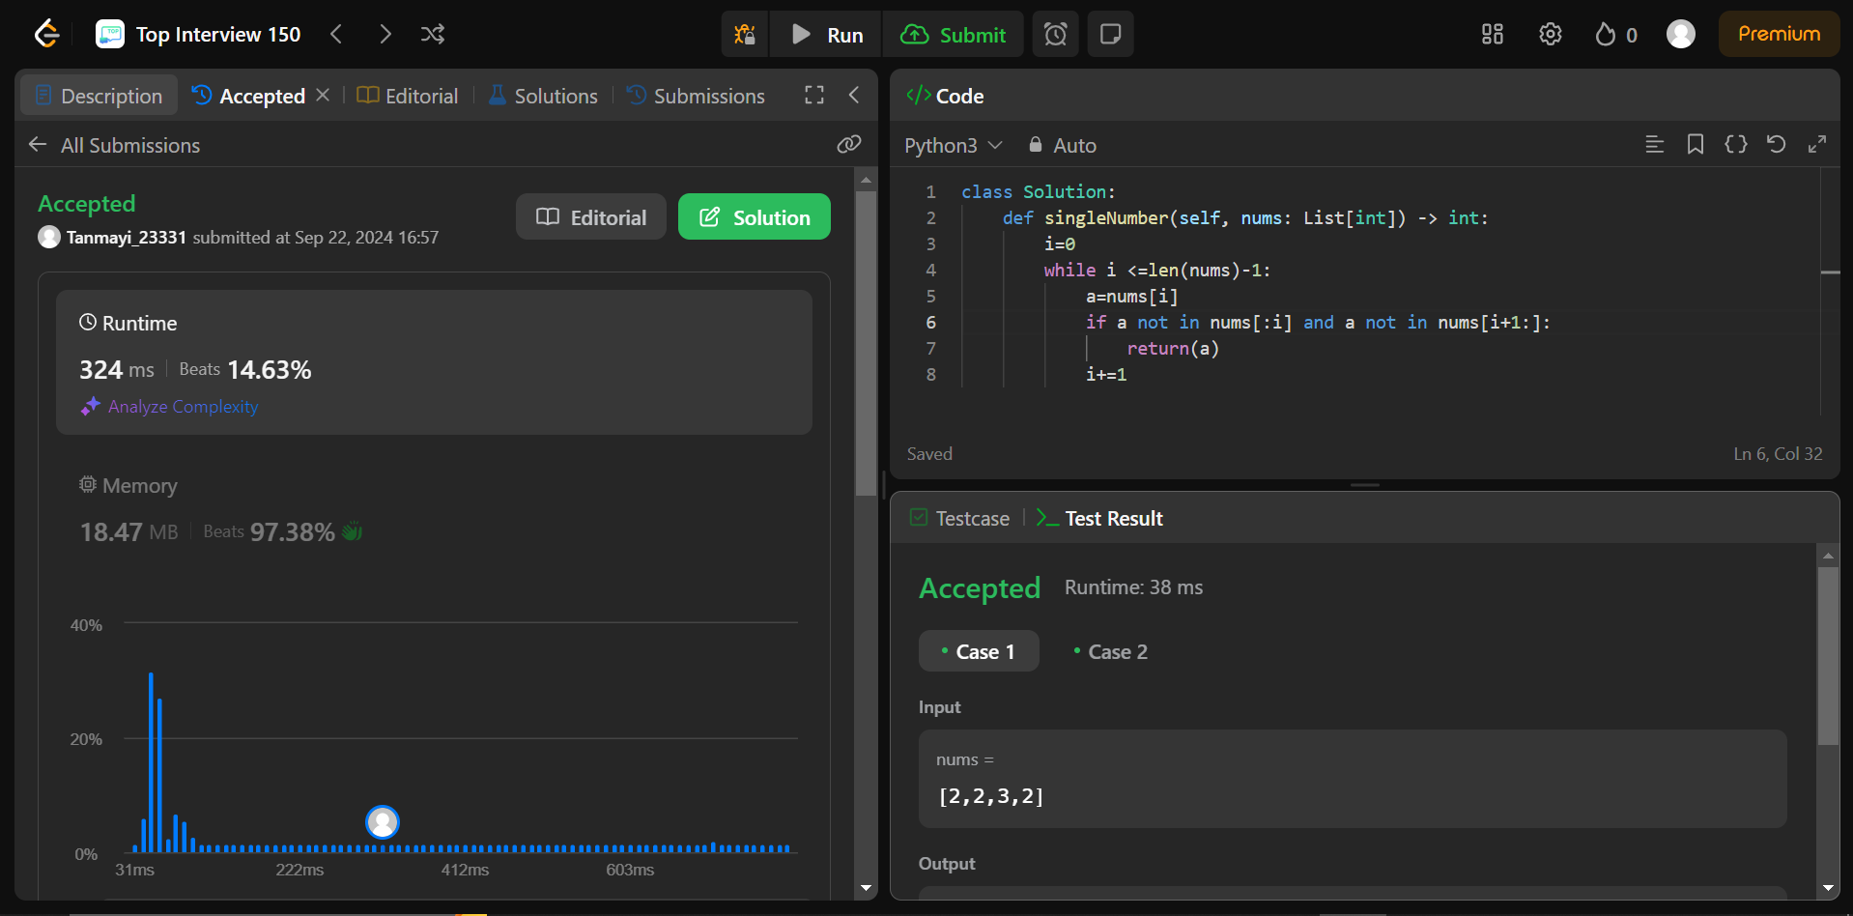

Code:  
nums = [0,1,0,1,0,1,99]

i=0

while i <=len(nums)-1:

a=nums[i]

if a not in nums[:i] and a not in nums[i+1:]:

print(a)

break

i+=1

Explain:

Here we are running a loop and finding out if the elements exists in the array elsewhere .If it doesn’t exist then print it .